**Practical 4(b).Create Web Form to demonstrate use of Adrotator Control. Add a XML file, name it "adds.xml"**

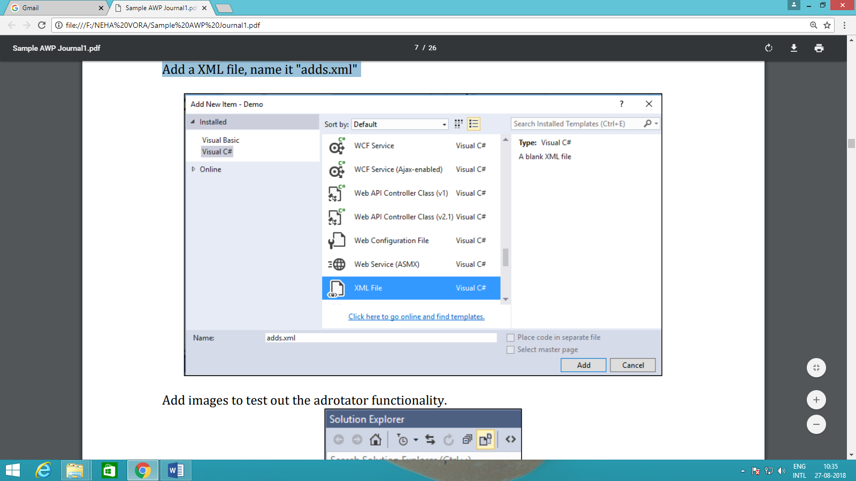

<Advertisements>

<Ad>

<ImageUrl>rose1.jpg</ImageUrl>

<NavigateUrl>http://www.1800flowers.com</NavigateUrl>

<AlternateText>

Order flowers, roses, gifts and more </AlternateText>

<Impressions>20</Impressions>

<Keyword>flowers</Keyword>

</Ad>

<Ad>

<ImageUrl>rose2.jpg</ImageUrl>

<NavigateUrl>http://www.babybouquets.com.au</NavigateUrl>

<AlternateText>Order roses and flowers</AlternateText>

<Impressions>20</Impressions>

<Keyword>gifts</Keyword>

</Ad>

<Ad>

<ImageUrl>rose3.jpeg</ImageUrl> <NavigateUrl>http://www.flowers2moscow.com</NavigateUrl>

<AlternateText>Send flowers to Russia</AlternateText>

<Impressions>20</Impressions>

<Keyword>russia</Keyword>

</Ad>

</Advertisements>

Default.aspx

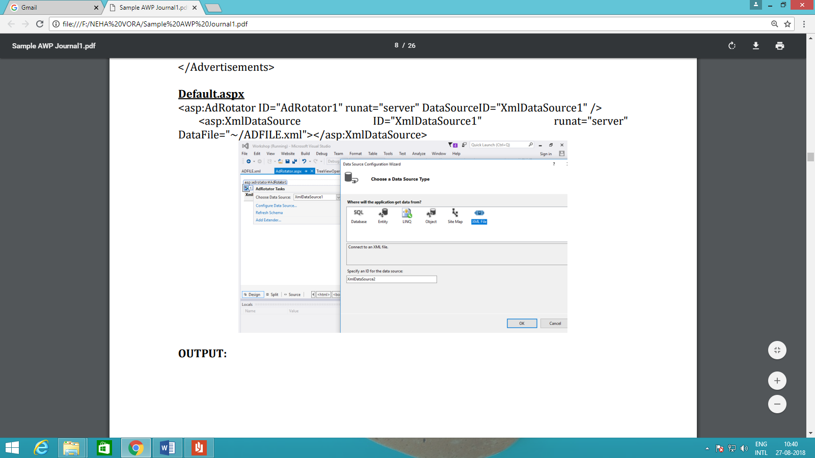

**Practical 4(c).Create Web Form to demonstrate use User Controls. Add Web User Control Website -> Add -> Web User Control and Name it ‘MyUserControl.**

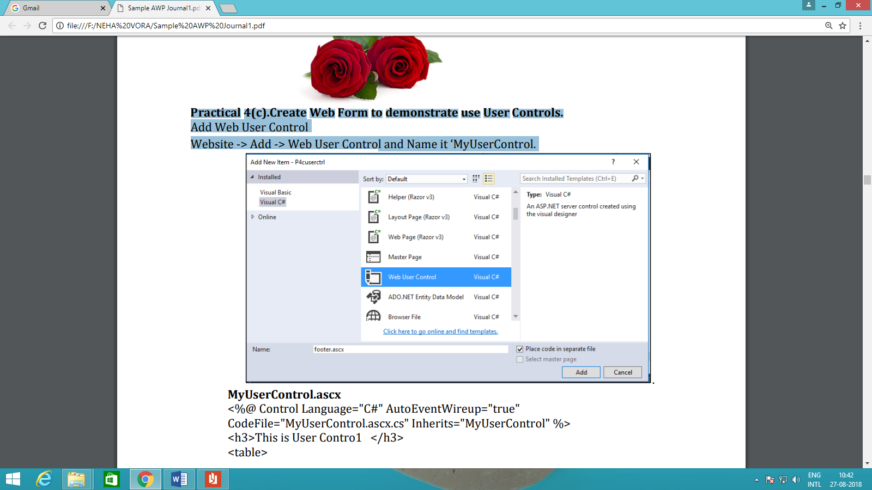

**MyUserControl.ascx**

<%@ Control Language="C#" AutoEventWireup="true"

CodeFile="MyUserControl.ascx.cs" Inherits="MyUserControl" %>

<h3>This is User Contro1 </h3>

<table>

<tr>

<td>Name</td>

<td>

<asp:TextBox ID="txtName" runat="server"></asp:TextBox>

</td>

</tr>

<tr>

<td>City</td>

<td><asp:TextBox ID="txtcity" runat="server"></asp:TextBox></td>

</tr>

<tr>

<td></td>

<td>

</td>

</tr>

<tr>

<td></td>

<td>

<asp:Button ID="txtSave" runat="server" Text="Save" onclick="txtSave_Click" />

</td>

</tr>

</table><br />

<asp:Label ID="Label1" runat="server" Text=" "></asp:Label>

**MyUserControl.ascx.cs**

protected void txtSave_Click(object sender, EventArgs e)

{

Label1.Text = "Your Name is " + txtName.Text + " and you are from " +

txtcity.Text;

}

UserControlDisplay.aspx

<%@ Page Language="C#" AutoEventWireup="true"

CodeFile="UserControlDisplay.aspx.cs" Inherits="UserControlDisplay" %>

<%@ Register Src="~/MyUserControl.ascx" TagPrefix="uc"

TagName="Student"%>

<!DOCTYPE html>

<html xmlns="http://www.w3.org/1999/xhtml">

<head runat="server">

<title></title>

</head>

<body>

<form id="form1" runat="server">

<div>

<uc:Student ID="studentcontrol" runat="server" />

</div>

</form>

</body>

</html>

OUTPUT :

